Completed Case Worksheet (NEW)

Summary:  
This will give an overview of the worksheet and it’s intended use. Examples are shown to highlight features of the worksheet. Will be covered section by section shown in the Worksheet

## Features:

* When you check a Satisfied box the row will turn Green
  + Graphical user interface, application, table

    Description automatically generated
* When you check a N/A box, the row will turn Grey
  + Table

    Description automatically generated
* You can only click 1 box per row, if you click Satisfied then you must unclick that before you can click N/A
  + 
* Blue buttons show and hide information sections to reduce clutter. Such as pay schedules, or showing Schedule documents.

* The Icon  available throughout the worksheet is used to provide helpful information about that specific item. Hove your mouse over the icon to reveal the details.
* Some calculations have been done for you to make case closing audit faster.



* There are a few sections where you can run forms directly from the worksheet instead of closing out and going to the case.

## Worksheet

### Case Information

This section is intended to provide critical information needed when closing a case. This information is pulled directly from the case. You also have the ability to run a form directly from the case.

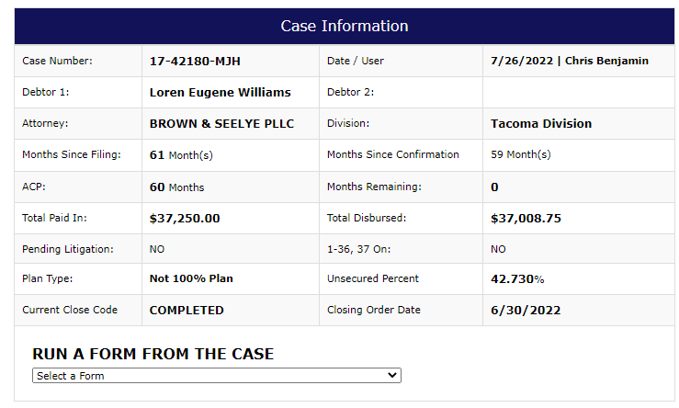

### BAPCPA Review

Information pulled directly from Case Modify. Note DSO Certificate Mailed will only show 1 date, is not per debtor.

## Plan Review

The plan review section requires that you pull up the plan and audit the case against the plan. Each section of the plan is separated out with questions for review. Some information will be pulled from Case Modify and indicated. If an item says “Review Plan Manually” then the information was not available for this case.

### Plan Documents

You can click the blue Show/Hide Plan Documents to reveal links to all Plan related documents associated with this case. Clicking the PDF icon on the left will open that document for viewing. By default this is hidden to save space.

### Plan Section 1

These questions pertain to 1.A, 1.B, and 1.C. If the Plan Narrative worksheet has been completed, then information will be pulled from that worksheet in the Plan Question column. If the worksheet has not been completed, then it will indicate to review plan manually.

### Plan Section 2

Information about the length of plan and the base are displayed. Helpful information is displayed along with the latest forum note in the base calc section of the forum for that case. Helpful information is displayed when hovering over the  image. The following fields are pulled from case: Months Since Filing, Months Since Confirmation, ACP, Plan Type, Base in Case Modify, IRS Pledge.

### Show/Hide Pay Schedules

The pay schedule information from the case has been brought into the worksheet for quick reference. You can click the blue Show/Hide Pay Schedules button to show or hide the information.

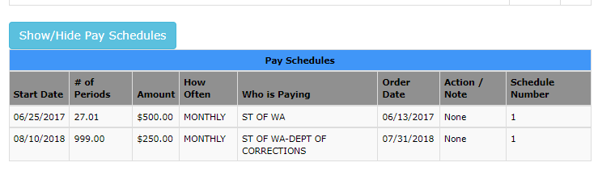

### Plan Section 3

Here you will be reviewing payment history and marking as appropriate.

### Show/Hide Petition, Schedules, and Statements Documents

This button will allow you to list out all Petition, Schedules, and Statements documents attached to this case for quick reference. Clicking the PDF icon on the left will open that document.

### Show/Hide Attorney Fees

This will show a table of the Attorney Fee’s found at the bottom of the Payee tab in the case. This is a quick reference to match with the plan.

### Plan Section 4

Verifying claims against the plan. Some information pulled in such as DSO case, whether the Notice of Final Cure has been sent (New tracking feature as of 7/26/2022), and the 4E information. The 4E question will pull in the 4E amount, the Equity, and a calculation of the Principal Paid to Priority creditors. The Compare Base will calculate the sum of unsecured claims, the unsecured percent from case modify, and then perform a calculation of the amount that unsecureds should receive. A link to open the Breakdown to Unsecureds is available as a button.

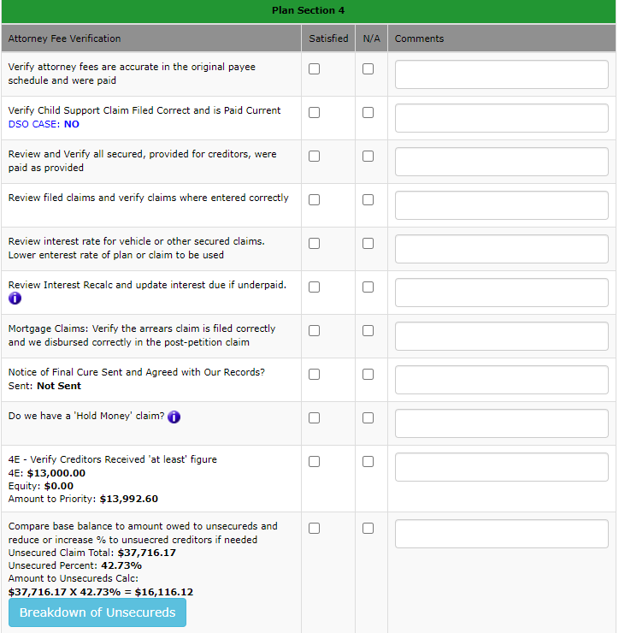

### Plan Section 5, 6, and 9

These sections each contain a single question to verify against the plan.

### Plan Section X

This section is regarding special provisions on the case.

If the **Plan Narrative Worksheet has not been completed**, then this section will indicate to review the plan manually for Section X and verify each provision.

**OR**

If the **Plan Narrative Worksheet HAS been completed**, then each provision will be listed to be verified separately.

You have completed the Plan Review section. Next you will review the entire case. The following pages break down the remainder of the worksheet.

## Case Review

The Case Review is completed after the case has been audited against the plan. Each item that is applicable to this case should be verified. This list serves as a reminder to thoroughly check each element of the case as the final audit before we close the case.

### Upcoming Matters

The Upcoming Matters section will display any matters on the docket dated Today or in the Future and will list their information from the Matters tab in the case for quick reference.

**If upcoming matters are found it will display them**

**OR**

**If no upcoming matters were found it will indicate no upcoming matters found.**



### Pending Motions Review

The first item can be answered based on the above information. The second item requires checking ECF. A single click button has been provided which will open this specific case in ECF in a separate window for comparing there are no future matters.

### Claims Review

This section requires a detailed audit of the claims for this case. The  will provide additional information that is helpful for each item you are auditing. The ability to run a form for this case, such as Notice of Final Cure, is provided using the dropdown at the top.

### Tax Data Section

The Tax section is to review tax returns that have been received on this case.

The Show/Hide Tax Return Documents and Return Data section will expand out 2 tables to reveal links to any filed tax returns in the system as well as show the breakdown from Tax Data from the case.

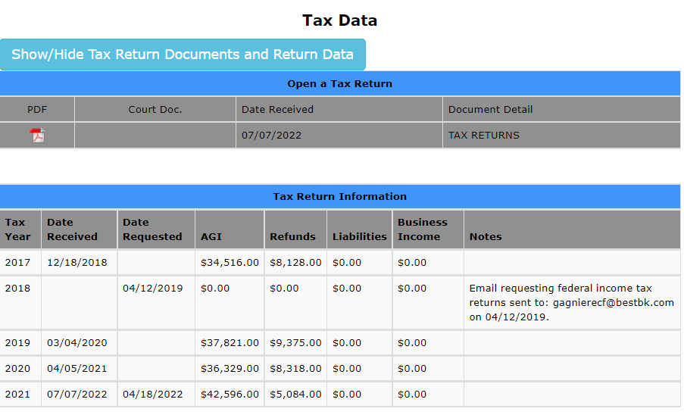

The Tax Data table has 3 questions regarding Tax Returns. Information is pulled from case flags if refunds **are committed** and if **annual** **1040** is required. Also, any missing tax returns will be listed for acknowledgement.

### Rescinding Order

The ability to run the Direct Pay or Employer terminate directive is available by clicking the respective buttons. Then indicate when done or N/A.

### Final Checks

This serves as final questions before marking the case as completed. Where available, the necessary information has been brought over to help indicate if the step has been completed. Such as updating the Close Code. This will also reference the Completing Cases Worksheet that lists all cases for Cutoff to indicate the status of this case on that worksheet. The Comment 1 and Comment 2 fields are also displayed to ensure they are accurate.

### Forum Note

This text field is intended for you to update the forum directly from this worksheet. Input the necessary remarks and click Create Forum Note. This will bring up another screen which you will leave on Create PDF, click Ok. The forum note will be generated on the case.

This Opens when you click Create Forum Note – Click OK

Example of Forum note that is Created:

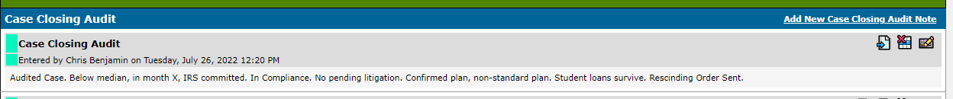

The final step is to create a snapshot of the worksheet. Click the image at the top-right 